Appendix E: Attachment of Technical specifications and Technical Conditions – Minimal Required Workflows

Workflow 1: Administration Workplace and display format
- Creating a workplace and editing the general terms and conditions of use Workplace - text, display conditions (external visibility)
- Setting graphic display parameters - selection from available Equipment and Services, custom name editing, colour selection for equipment, daily/weekly/monthly/timeline calendar display including naming of days of the week and marking of weekends and Czech public holidays, display of working hours
- Setting the content of the home page - notifications, chat, calendar/list of Services
- Project template settings - definition of required information (project request content), phases/milestones and project acceptance workflow (peer review, automatic/manual approval)
- Requirement template settings - definition of required information and requirement acceptance workflow (automatic/manual approval) see Workflows 3 and 4
- Setting up and changing Workplace users, including their roles

Workflow 2: Equipment administration
- Creation (or parameter modification) Equipment - filling in basic parameters (name, description, associated Workplace, working hours, price categories, reservation length restrictions, equipment reservation restrictions, reservation creation/cancellation date restrictions, possibility of changing reservations during measurement and inviting other users to use free time slots, etc.), assigning a certificate; also allows bulk entry of parameters for multiple individual Equipment items (typically in the case of individual parking slots, cages in animal facilities, etc.) and, for this purpose, grouping of Equipment
- Import (or manual entry) of prices - simple import of prices valid for the given equipment, including a breakdown into direct costs, overheads and profit, or the option of manual entry directly in the system
- Creation (or modification of parameters) of certification - assignment for individual Equipment, access permission/restriction parameters, user assignment, definition of certification validity, possibility of prioritising reservations by certain users with the relevant certification (e.g. internal); possibility of addressing time limitations during working and non-working hours
- Modification of user parameters - contact details, assigned certifications, assigned projects, setting of default parameters
- Project creation (or parameter modification) - modification of validity, limits, assigned users

Workflow 3: Service Administration
- Creating (or modifying) service parameters - filling in basic parameters (name, description, associated workplace, associated equipment, price levels, etc.), creating a service workflow
- Import (or manual entry) of prices - simple import of prices valid for a given service, including a breakdown into direct costs, overheads and profit, or the option of manual entry directly into the system
- Creating (or editing) user parameters - contact details, assigned projects, setting default parameters
- Creating (or editing parameters) a project - editing validity, limits, assigned users

Workflow 4: Basic interaction with projects and reservations
- Submitting a project request to the system - access to the project request form for access to the workplace without or after authentication, filling in the project request by the user, sending, access route.
- Evaluation of the project request by the workplace - technical evaluation (Workplace leader)/submission for peer review (Evaluator)/initial confirmation, acceptance/rejection/request for additional information on the project request, submission of terms of use, acceptance of terms of use or price list.
- Administration of the project application after approval - transfer to active project, definition of time and financial limits, assignment of the project to the user.
- Creation of an offer - allows you to select Equipment and Services items and their quantities, assign a specific price level, set a discount (in %, in CZK) and generate a predefined Word template, into which the date of creation of the offer and the unique reference number (ID) of the offer are entered. The offer can be created in various currencies, at least CZK, EUR (linked to the economic system to obtain the current exchange rate or possibility to set the exchange rate valid for a certain period, e.g., half a year). The offer is created for already registered users, but also for potential new users in anonymous mode (e.g. generally for users from the commercial sphere), where it will be possible to assign the offer to a specific name from this anonymous mode when the unregistered user becomes a new, registered, the offer can be converted into a Request, and documents can be uploaded.
- Active project administration - modification of financial resources and assignment of users to the project.
- Project extension - sending a request to extend the validity of the project.
- Project termination and archiving - removal from the list of available projects for all users.
- Entering/cancelling an equipment reservation by a user - selecting a time period in the calendar or button, selecting/editing the time period, selecting from available equipment (one or more pieces of equipment), selecting from available projects, confirming the price of the service
- Entering/cancelling an instrument reservation by a workplace employee - selecting a time period in the calendar or using a button, selecting/editing the time period, selecting a user, selecting available projects, selecting an instrument
- Entering/adding a service request - searching and selecting a service from a list (or other graphical display, e.g. containers), filling in the required information, adding additional consumables (and individual items, e.g. with/without assistance, including data evaluation, etc.), adding information to an open form, sending, possible service statuses - requested, ordered, in process, ready to issue an invoice, sent for reimbursement, paid
- Acceptance of service request - rejection, sent back for completion, proposal to change the scope of service, sending a price quote, communication via chat/email. Confirmation of the price quote for the scope of service by the applicant.
- Delivery of service results - sending a notification to the user about existing service results - chat/email/notification system, acceptance, non-acceptance of results, modification of the scope of service, approval of changes to the scope of service, termination of service
- Service performance report – option to download a service performance report with basic information – who performed the measurement, when, for which project, responsible person from the workplace, etc.
- Service billing – the service is reported in the following billing report as completed, ready for invoicing
- Archiving of completed services – transfer to the list of finalised services
- Archiving of completed projects – archiving after project completion or after a defined period of time has elapsed since the project expired. Removal from the database of active projects. The project is no longer offered to users when booking/creating a request.

Workflow 5: Billing for services and equipment provided
- The billing process can be initiated by:
  - the workplace leader at any time
  - the workplace administrator (Workplace admin) at any time
  - initialisation takes place automatically according to preset parameters (monthly, quarterly, annually, period from - to)
- Manual initiation:
  - selection of billing documents (one of the options):
    - The Workplace Leader selects Project Guarantors, projects, instruments/services (leaving the project field blank means all reservations for the given PI; leaving the instruments/services field blank leads to the selection of all project reservations), selects the time period for generating reservations
    - The Workplace Admin selects the Project Guarantors, projects, workplaces (1-n workplaces within the Workplace network), instruments/services (same logic as in the previous point) and selects the time period for generating a list of services used in the status ready to issue invoice and past equipment reservations (including those cancelled late and subject to a cancellation fee)
- Automatic initialisation:
  - at the end of the billing period, the system automatically generates a list of reservations for individual projects and sends it to the workplace manager
- After checking, the workplace manager approves the list of reservations/requests, or has the option to correct the data and generate a new report.
- The head of the workplace has the authority to apply a discount or completely waive the fee for a specific reservation/request (e.g. in the event of a measurement error, destruction of a sample, etc.) with appropriate justification.
- The report/statement allows you to click on the details of all service requests and equipment reservations for proper statement verification.
- The report/statement contains a list of services/equipment used, the unit rate, the discount applied, the number of units used and the total price to be paid separately for each workplace, with the direct costs, overheads and profit calculated.
- The billing can be generated collectively for 1-n workplaces and is sent for approval to all relevant workplace managers.
- When the report is sent, an email notification is sent and a notification is also generated in the system, alerting the workplace manager/project guarantor that they have an unresolved activity in the system = the need to approve/disapprove the report.
- After approval by the head(s) of the workplaces, this list is forwarded/sent to the project guarantor (including a breakdown of prices according to price categories linked to the project(s)), who has the option to:
  - approve it (in the case of MUNI users, they will add a list of internal orders for payment; in the case of external users, they will provide billing details, including the order number generated from the external financial system of the home institution).
  - reject it and add a comment to the parts of the list to which they have reservations
- In the event of reservations about the report, the list is returned to the head of the workplace for another round of checks and possible adjustments.
- The status of all services and equipment in the report will be changed so that they cannot be included in further billing (= they will be switched to the status sent for reimbursement).
- If not approved, the report, including reservations, is forwarded to the Workplace Admin for verification and possible adjustment of billing parameters.
- Other options for generating invoice requests and recording payment status depend on the level of connection with EIS (see Workflow 7):
  - Manual recording of payment status - performed by the Workplace admin
  - Automatic recording of payment status - in connection with EIS

Workflow 6. Generating statistics on project utilisation, service utilisation and equipment utilisation
- The billing process can be initialised by:
  - Workplace manager - selects a list of services and equipment (1-N) for their workplace, project (0-N), users (0-N), and time period. A list is generated only for their own workplace.
  - Admin - selects the workplace (1-N), services and equipment (0-N), projects (0-N), users (0-N) and time period
  - project guarantor - selects the project (1-N), service and equipment (0-N), users assigned to the project (0-N), and time period
- The system displays information about individual reservations in the graphical environment of the reservation system and allows data to be exported in at least .csv format
- The system allows for easy filtering of the data displayed in the graphical interface.
- The system allows you to set fields for data export (e.g. for the purposes of equipment logbooks (user, institution, project, from – to, student YES/NO, etc.).

Workflow 7: Economics in connection with EIS (MUNI economic information system) – this workflow will be required in perspective of 3-5 years
- Equipment:
- Devices can be linked to workplace assets in EIS
- Workplace:
- Resources (orders according to the EIS code list) are assigned to the workplace, to which payments from issued invoices are received
- 1-n orders can be assigned to the workplace
- Each order can be assigned to exactly one price category
- Price:
- Price broken down into direct costs, overheads, profit (linked to accounting analytics in EIS).
- Currency – CZK, EUR, USD (linked to EIS, from which it takes the current exchange rate)
- A source of financing can be linked to the project (will be included in the invoice request)
- Approval of price quote and order placement (guarantor/PI)
- Issuing a quote via the booking system
- Linking the offer to the project – 1-n offers can be linked to the project
- Approval by workplace leader
- Approval by guarantor/PI
- For persons from MU:
  - Transfer of data to the EIS application
  - Finalisation of official order in EIS application (addition of funding sources, where multiple sources can be entered for project payment)
  - Submission for issuance of internal order in EIS
  - Issuance of internal order, approval by financial control (ordering department)
  - Transfer of order number to the reservation system
- For external persons:
  - Issuance of an order by an external entity, manual entry into the reservation system (in the form of an attached document and addition of the order number)
- Advance invoice (applies only to external parties, may not be issued)
- Request for issuance of an advance invoice for the full amount – e-mail with supporting documents to Economic Department with a link to offers in the booking system
- Issuing an advance invoice, sending it to the customer
- Recording of the invoice in the reservation system (manual entry of the invoice number)
- Advance invoice payment, payment information in the booking system (automatically according to the invoice number and payment status in EIS)
- Project activation (system) – the project is active for making reservations
- Accepted offer and approved order saved for the project (links)
- Persons who can make reservations are registered for the project = guarantor/PI + collaborators (the project will be offered to these persons when a reservation is created)
- Maximum budget and credit recorded for the project – statement of utilisation (approved, utilised, remaining)
- Billing for measurements and services on the project – cumulatively for all measurements and services within a single project (at the end of the month / at the end of the quarter / at the end of the measurement)
- Generation of report see Workflow 5: Billing for services and equipment provided
- Update of the utilisation overview (approved, used, remaining)
- Request for invoice issuance (system)
- Generated immediately after approval of the billing
- Contains a breakdown of the price by source of funding (see points 2. Workplace and 3. Price)
- Contains a link to the internal order; the external order is attached
- If necessary, allows additional sources of funding to be entered if these were missing at the order stage
- The request is sent to fakturace@....
- Issuing an invoice (Workplace accounting department)
- Preparation of internal invoice in EIS
- Sending to internal faculty /external entity
- Entering the invoice number into the reservation system (preferably automatically by the system)
- Recording of payment in the reservation system (invoice number and document for credit)
- Project completion (PI/guarantor)
- Price limit exhausted / end of measurement

Workflow 8: Access to equipment
- User registration (time-limited, e.g., valid for one year)
- User approval by Workplace Leader and role assignment (one of the options);
  - approval can be automatic
  - Manual approval by Workplace Leader
- Submission of a project application (one of the options):
  - Filling out the project application form and then sending it for technical evaluation and review
  - Automatic project creation without the need to fill in a project form
- By submitting a project application, the user assumes the role of project guarantor for that project application.
- In the case of technical evaluation and scientific evaluation of the application, it is sent to the Workplace Leader (who performs the technical evaluation or delegates it), and then sent to the Evaluator
- Evaluation of the project application:
  - acceptance
  - request for additional information
  - rejection
- The applicant is informed of the outcome of the application evaluation (via the booking system or by email). In the case of a positive evaluation (one or more of the options):
  - Confirmation of general terms and conditions of use
  - Confirmation of the price list for services
  - Confirmation of payment source (for MUNI)
  - Direct access to workplace resources without the need for further administration
- The project guarantor can assign this project to other users of the system or send an invitation to register in the system
- The project guarantor and team members (one of the options):
  - They will undergo training for independent use of the workplace resources and will then be assigned the appropriate certification by the workplace
  - They already have the necessary certification and can access workplace resources
  - Standard certification (e.g. limiting the use of parking spaces to a defined number of hours per week) is automatically assigned to all project members
  - The user does not need any certification
  - The user does not use the equipment themselves, but requests it from the workplace via project chat (or email)
- Creating a request:
  - The user will see the selected equipment from those available to them in the calendar. By selecting a time slot or clicking the New Request button, they initiate the creation of a request
  - On the reservation request creation tab, the applicant has the option to edit the start and end of the reservation; they must select a project from the menu; they must select equipment from the menu; can select additional equipment/materials for equipment that has them available; can select multiple units of equipment (computers in a classroom, places in a greenhouse) for equipment that has multiple units; can add any comments to the request; can select the option to create a recurring request; can select the option to send the reservation to the calendar by email
  - For paid services, the user will see the price of the service depending on the selected Project, from which the financing will subsequently take place
  - The user can cancel the created request according to the parameters of the given equipment
  - If the equipment parameters allow it, the user can flexibly shorten the reservation during the measurement (e.g. when working on the microscope faster) and notify users with reservations for that day that the microscope is available. If one of the users actively takes over the reserved slot, a reservation for the new user is automatically created. If no one takes over the reservation, it remains at the original length for billing to the original user.
  - When making a reservation, the user can set a notification to be notified in advance of the reservation by email (e.g. 1 day in advance, 1 week in advance, on a specific date, etc.) so that they do not forget to show up or can cancel the reservation in time.
- The implementation of the request can take on various statuses:
  - requested = status prior to approval, requires approval by the workplace
  - blocked = preliminary reservation that expires at a specified time before the measurement date unless it is converted to reserved status
  - reserved = status after approval
  - in process = typically for a service that may not have a clearly defined implementation time, unlike equipment, but also for equipment that may have long reservations (in the order of days or weeks)
  - results delivered = delivery of a link to the results; formal termination of the request
  - ready to issue an invoice = inclusion in a future billing batch
  - sent for reimbursement = approved billing by PI
  - paid, unpaid = recorded automatically via the POH number on the EIS or manually by the administrator
- Copying a request:
  - Equipment reservations can be easily copied using Ctrl+C/Ctrl+V or a simple button, so that a pre-filled previous request is transferred and only partial parameters (from-to, Project) are adjusted
  - Similarly, service requests can be copied by adjusting partial parameters such as the number of analyses, samples, etc.
- Entering regularly recurring requests:
  - When reserving equipment, you can select the repeat option (monthly, weekly, annually, other), typically in the case of regular maintenance, teaching, etc.

Workflow 9: Access to the service
Same as Workflow 8 up to the "create request" section
- Creating a service request:
  - Fill in the form specific to the service in question, attaching any required documents if necessary; part of the request is to fill in the Project to which the request relates
  - Evaluation of the request by the employee or workplace manager (service administrator)
  - Communication between the user and the workplace via the request chat
  - Reopening of the request for completion by the applicant
  - Sending the offer to the user
  - Approval of the offer
  - Service implementation, workplace reserves equipment and materials for the relevant project and user as part of service implementation
  - Delivery of results
  - Termination of service
- When a service request is created, a form is generated for this service, which contains at least the following sections:
  - Request – information about the requested service, including detailed information about samples (if sample processing is part of the service)
  - Equipment reservation allows members of the workplace to make reservations for equipment for a given service
  - Documents - allows users to attach files
  - User vs. Workplace chat
  - Chat2 within the Workplace (hidden from users)
  - Result document(s) or other form representing the results of the service
- The service request goes through various stages:
  - requested = status prior to approval, requires evaluation/assessment of the request and approval by the workplace
  - evaluation = process of evaluating the request, which may lead to approval = status accepted, refused, or changed, when the workplace proposes a different procedure and service needed to achieve the result
  - from the changed status, the request is sent for acceptance by the customer / accepted by customer or refused by customer
  - in process = processing of the service request has started and is ongoing
  - results delivered = link to results provided
  - results accepted = formal termination of the request
  - ready to issue an invoice = inclusion in a future billing batch
  - sent for reimbursement = approved billing by PI
  - paid, unpaid = recorded automatically via POH number on EIS or manually by administrator
  - finished = final archiving of the request, deactivation of chat (no further posts can be added to the communication thread, but the communication that has taken place is retained and archived)

Workflow 10: Design and functionality of requested calendar views in the booking system
The design and functionality of the requested calendar views were inspired by commercial calendars (e.g., Google Calendar, Microsoft Outlook). The booking calendar will support four views:
- Day view
- Week view
- Month view
- Timeline view
The day view (an example of which is shown in Figure 1):
- Shows the agenda of user-selected reservable equipment for a single day
- Shows the equpment on the horizontal axis of the calendar and time slots on the vertical axis of the calendar. Visualisation of equpment on the horizontal axis is desirable, since most common computer monitors have display aspect ratios of 16:9 or 16:10
- Shows the agenda for as much equipment as possible without the need for horizontal scrolling
- Shows the date, for which the view is showing the agenda
- Shows control elements for switching to the previous or the next day

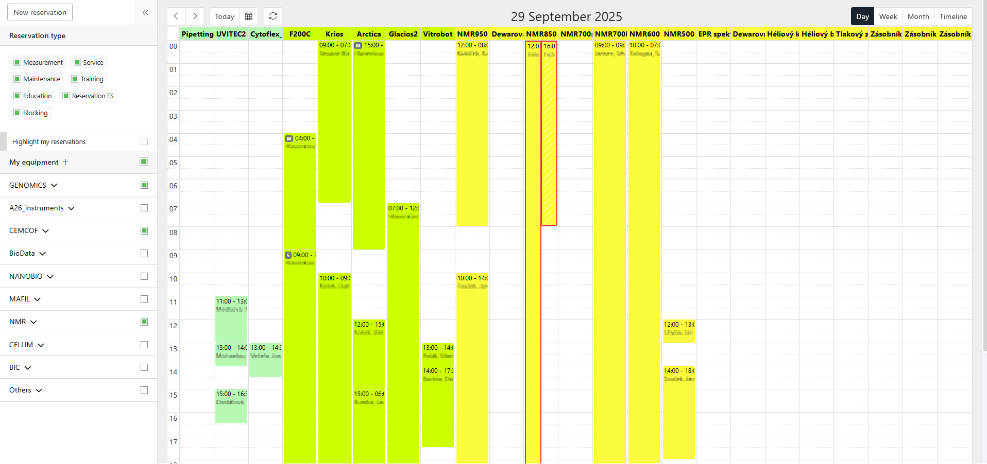
The week view (an example of which is shown in Figure 2):
- Shows the agenda of user-selected reservable equipment for a single week. The week starts on Monday and ends on Sunday by default with the user being able to hide weekends from the booking calendar
- Shows the days of the week on the horizontal axis of the calendar and time slots on the vertical axis of the calendar. Reservations of user-selected equipment for a day are shown inside the column of that day. The width of visualisations of individual reservations is dynamically adjusted, so that all reservations of user-selected equipment fit inside the column and are shown at the same time
Figure 1: An example of the day view of the booking calendar
- Shows the agenda for as much equipment as possible without the need for horizontal scrolling
- Shows the dates of the first and last day of the week, for which the view is showing the agenda
- Shows control elements for switching to previous or next week
The month view (an example of which is shown in Figure 3):
- Shows the agenda of user-selected reservable equipment for a single month
- Enables the user to specify whether they want to show weekends
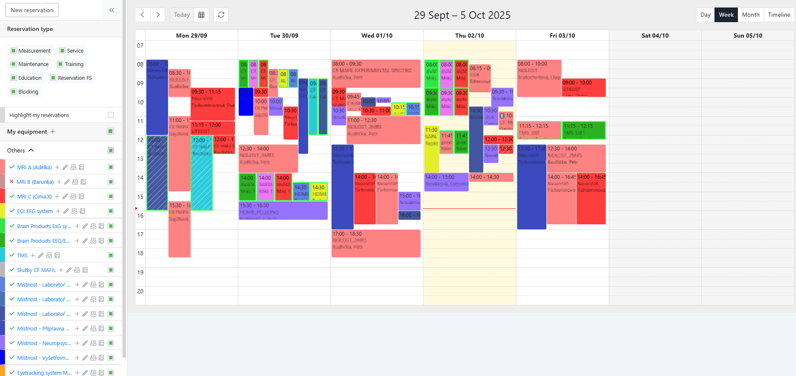
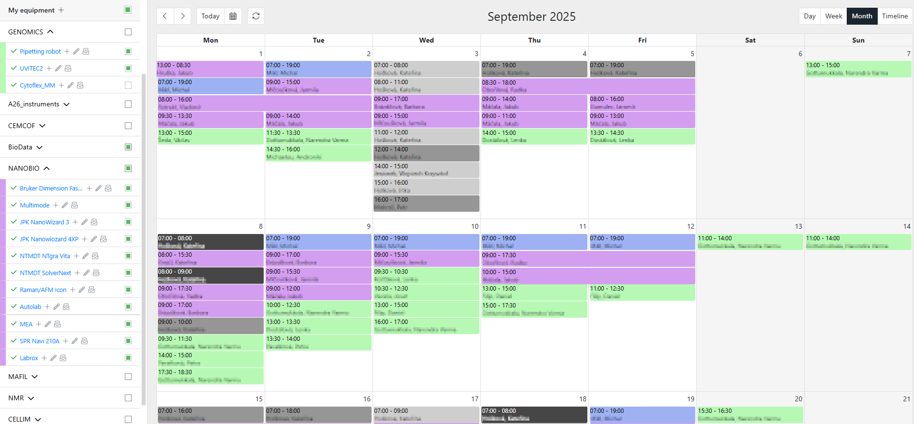
- Shows the days of a week on the horizontal axis of the calendar. Each day of the month is represented by a single cell. The cells are laid from left to right and from top to bottom. Reservations of user-selected equipment for a day are shown inside its cell one below another and are sorted by the start time of the reservation. The width of visualisations of individual reservations is statis, except for multi-day reservations, which are rendered through cells of every day the reservation spans
Figure 3: An example of the month view of the booking calendar
- Shows the agenda for as much equipment as possible without the need for horizontal scrolling. Vertical scrolling is inevitable in this view
Figure 2: An example of the week view of the booking calendar
- Shows the name and year of the month, for which the view is showing the agenda
- Shows control elements for switching to previous or next month

The timeline view (an example of which is shown in Figure 4):
- Shows the agenda of user-selected reservable equipment for a user-specified time period
- Enables the user to specify whether they want to show weekends
- Shows the date (and time when the user specifies a short time period, which leads to increased granularity of the calendar view) on the horizontal axis of the calendar and the equipment on the vertical axis of the calendar. Reservations of a piece of equipment are shown inside its row one after another
- Increases the size of visualisation of short reservations, so that they are noticeable even when the user selects a long time period of the view
- Shows the agenda of as much equipment as possible
- Shows the start and end dates of the visualised time period
- Shows control elements for switching to previous or next time period
All the views will support the following functionality:
- The user will be able to select equipment, which agenda will be shown in the calendar, from a pool of equipment that are available to the user, from any workplace they have access to
- The user will be able to set the ordering of equipment in the calendar if they so desire
- The user will be able to manually group equipment in the list of selected equipment
- The user will be able to set a colour to each piece of equipment in the calendar if they so desire. The agenda of the piece of equipment will be visualised in the calendar using the chosen colour. The colour picker will support choosing any colour from the standard 8-bit RGB range (0 – 255). The text colour will be automatically set to either black or white to preserve readability when setting a dark colour for the visualisation
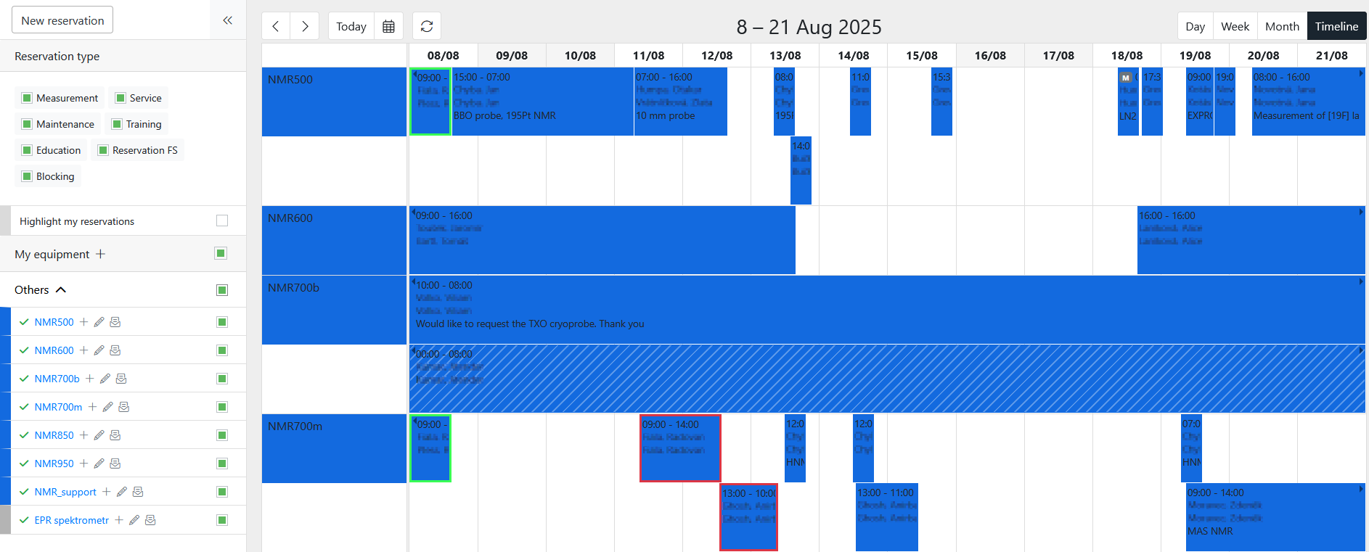
- The user will be able to highlight their own reservations if they so desire
Figure 4: An example of the timeline view of the booking calendar
- The user will be able to show/hide reservations of particular types (e.g., measurement/standard reservation, service, maintenance, training, education, service request reservation)
- The user will be able to show/hide reservations of a particular piece of equipment from their set of selected equipment
- There will be quick way for a user to open a compact generic calendar and navigate to a desired date
- The particular type of reservation for reservations that are not measurements/standard reservations (e.g., service, maintenance, training, education, service request reservation) will be visualised for each reservation in the calendar
- Reservations that are part of an overlap (i.e., two or more reservations of a single piece of equipment, where the start or end time of a reservation is between the start and end time of at least one other reservation) will be highlighted in the calendar while preserving the colour assigned to the piece of equipment by the user
- Reservations that book multiple pieces of equipment will be highlighted in the calendar while preserving the colour assigned to the piece of equipment by the user
- Reservations that are yet to be approved by a workplace employee will be highlighted in the calendar while preserving the colour assigned to the piece of equipment by the user
- Basic information about a reservation (e.g., time, project, for whom it was made, a short note) are shown in the reservation’s visualisation in the calendar. It is possible to configure (on the level of a workplace) what information are shown.
- Details of a reservation (e.g., reservation number, who made it, for whom it was made, short name of the piece of equipment, date and time, and project) are shown when hovering over it. It is possible to configure (on the level of a workplace) what information are shown.

