Guideline – E-ZAK

E-ZAK is an electronic tool used for communication between contracting authorities and suppliers during tender procedures.

Here is a short description about how to proceed as a supplier who wants to get involved in any tender procedure.

1. **Requirements for the system operation**

This web application may be run via every common web browser (Mozilla Firefox, MS Internet Explorer, Chrome,..). Please note: <http://java.com/en/download/faq/chrome.xml> - Enabling NPAPI in Chrome Version 42 and later.

Every user needs to use browser supporting JavaScript and allowing Cookies.

1. **Registration of suppliers**

To be able to log in the E-ZAK is needed to create new user account

* to complete the registration into the system if you are asked to do so by the contracting authority by clicking on the link in the email you´ve received by the contracting authority:

or

* if none of the members of your organization have an E-ZAK account, use the link **"*Registrovat dodavatel*e"** in the registration block on the bottom left (see on the picture below):

At the beginning of a new registration select whether you are natural (*Fyzická osoba*) or legal entity (*Právnická osoba*). The supplier´s form will accommodate accordingly to your choice.



***FYZICKÁ OSOBA* (natural entity):**

* fill in: Surname (*Příjmení*) – First name (*Jméno*) – Degree (*Titul*) – Phone number (*Telefon*) – Fax – E-mail – Description (*Popis*) – Mail address (*Poštovní adresa*) – Country (*Země sídla/místa podnikání/bydliště*) – Company ID (*IČO*) – Type of activities (as a supplier) (*Druh aktivit*) – choose: supply(*dodávky*)/services(*služby*)/public works (*stavební práce*)
* Contact person (*Kontaktní osoba*) – fill in only in the event that the contact person differs from the supplier.

***PRÁVNICKÁ OSOBA* (legal entity):**

* fill in: Company name (*Obchodní název*) - Description (*Popis*) – Mail address (*Poštovní adresa*) – Country (*Země sídla/místa podnikání/bydliště*) – Company ID (*IČO*) – Type of activities (as a supplier) (*Druh aktivit*) – choose: supply(*dodávky*)/services(*služby*)/public works (*stavební práce*)
* Contact person (*Kontaktní osob*a): Surname (*Příjmení*) – First name (*Jméno)* – Degree (*Titul*) – Title (*Funkce*) – Phone number (*Telefon*) – Fax – E-mail

Credentials (*Přihlašovací údaje*): login name (*Přihlašovací jméno kontaktní osoby*) and password (*Heslo*) for the user. You need to verify the password in the space “*Ověření hesla*” by re-writing the password. Then click on the button “*Pokračovat v registraci*” to complete the registration. You´ll see an overview of all inserted information. In this step you’ll be required to sign the registration with your electronic signature - click on the link “*Obejít elektronický podpis*“ to skip this requirement (see on the picture below).



1. **Log in/log out**

To **log in** the system you need to fill in your credentials on the left in the block called **„*Přihlášení*“** (Username – *Uživatel*, Password – *Heslo*).

**Forgotten password?**

In case you forget your password, use the link „*Zapomenuté heslo*“. You´ll be required to provide system with your login name and email address where the system immidiatelly send you over an email with instructions how to reset your password.

**Log out** – automatically after 60 minutes without activity or by clicking on the link **„***Odhlásit***“**

1. **Authorization**

You have to assign a specific person to a specific public contract in the block in the tender detail called “*Oprávněné osoby za dodavatele*”, and proceed in two steps. First, click on the link “*Přidat oprávněnou osobu*” and choose a user from your company who has a valid account, and second, set his/her permissions to publiccontract.

Permissions:

* respond to the order (*odpovědět na objednávku*)
* answer to the call (*odpovědět na výzvu*)
* answer to individual messages (*odpovídat na individuální zprávy*)
* invalidate tender (*zneplatnit nabídku/žádost o účast*)
* notify about messages to the tender procedure (*upozorňování na zprávy k zakázce*)
* observe electronic auctions (pozorovatel *elektronické aukce*)
* enter new auction values (*zadávat nové aukční hodnoty*)
* set other authorized persons (*nastavit další oprávněné osoby*)
* person authorized on behalf of the organization (*osoba pověřena za organizaci*) – basic permissions needed for the user to be assigned to the relevant public contract

1. **Tender overview and details**

If you click on the link <https://zakazky.muni.cz/vz00004437> you can display detailed information about it.

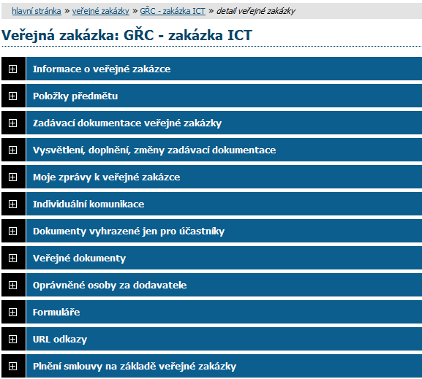

**Information about the public tender** (*Informace o veřejné zakázce*)

**Tender documents** *(Zadávací dokumentace veřejné zakázky)*

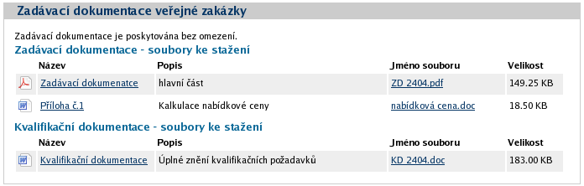

To download the tender documents click on the link in the third column (*Jméno souboru*).

**Explanation, additions and amendments in the tender documents** *(Vysvětlení, doplnění, změny zadávací dokumentace)*

Via this section is each registered supplier able to ask the contracting authority for additional information (P*oslat žádost o vysvětlení zadávací dokumenta*ce). The answer to supplier’s request will be delivered into this section as well.

**My messages in the tender procedure** *(Moje zprávy k veřejné zakázce)*

Each registered supplier might read internal messages in this section by clicking on the link in the column “*Předmět*”). Users are informed about every incoming message via email.

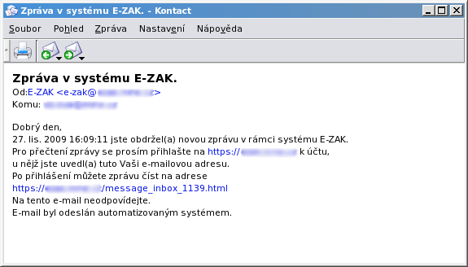

Individual communication (*Individuální komunikace*)

Documents reserved only for participants (*Dokumenty vyhrazené jen pro účastníky*)

Public documents (*Veřejné dokumenty*)

Supplier’s authorized persons (*Oprávněné osoby za dodavatele*)

Forms (*Formuláře*)

URL links (*URL odkazy*)

**Submitted electronic tenders (*Odeslané elektronické nabídky*)**

Public contract performance (*Plnění smlouvy na základě veřejné zakázky*)

1. **Tender submitting**

A tender has to be submitted within the time limit for the submission of tenders.

**1. step:**

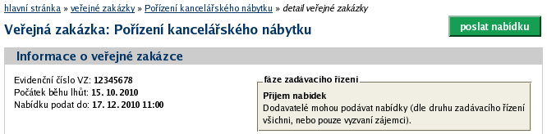

To submit a tender first click on the green link “*Poslat nabídku*”. A form for compile of the tender launches.

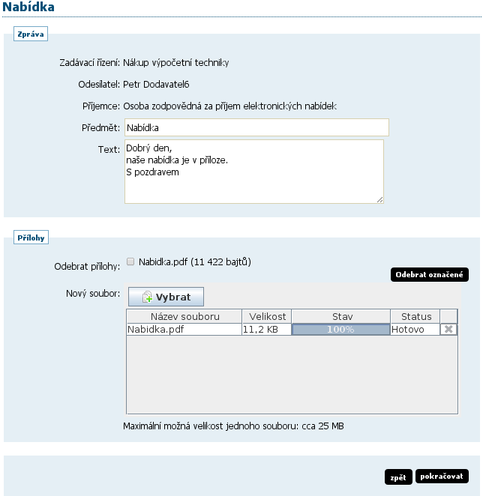

**2. step:** Subject Matter: Tender (*Předmět: Nabídka*); Short message/description (*Text*); Attachments (*Přílohy*) – Delete attachment (*Odebrat přílohy*)/New file (*Nový soubor*)🡪Select (*Vybrat*); Back (*Zpět*)/Continue (*Pokračovat*)

**3. step:** Electronic signature or click on the link “*Obejít elektronický podpis*“ to skip this requirement.

**4. step:** You will receive an automatic message about the tender submitting and you can also check the status in the section *Odeslané elektronické nabídky*.

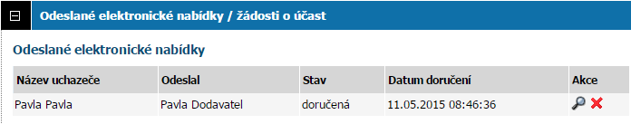

Status of the tender: delivered (*doručená*), void (zneplatněná), late delivery – automatically rejected (*doručená po lhůtě*), opened (*otevřená*), complete (*úplná*), incomplete (*neúplná*)