Guideline – E-ZAK

E-ZAK is an electronic tool used for communication between contracting authorities and suppliers during tender procedures.
Here is a short description about how to proceed as a supplier who wants to get involved in any tender procedure.

- Requirements for the system operation
This web application may be run via every common web browser (Mozilla Firefox, MS Internet Explorer, Chrome,..). Please note: http://java.com/en/download/faq/chrome.xml - Enabling NPAPI in Chrome Version 42 and later.
Every user needs to use a browser supporting JavaScript and allowing Cookies.

- Registration of suppliers
To be able to log in the E-ZAK, you need to create new user account
- to complete the registration on the system if you are asked to do so by the contracting authority by clicking on the link in the email you received from the contracting authority:
or
- if none of the members of your organization have an E-ZAK account, use the link "Registrovat dodavatele" in the registration block in the bottom left (see on the picture below):

At the beginning of a new registration, select whether you are natural (Fyzická osoba) or legal entity (Právnická osoba). The supplier´s form will accommodate your choice accordingly.
FYZICKÁ OSOBA (natural entity):
- fill in: Surname (Příjmení) – First name (Jméno) – Degree (Titul) – Phone number (Telefon) – Fax – E-mail – Description (Popis) – Mail address (Poštovní adresa) – Country (Země sídla/místa podnikání/bydliště) – Company ID (IČO) – Type of activities (as a supplier) (Druh aktivit) – choose: supply(dodávky)/services(služby)/public works (stavební práce)
- Contact person (Kontaktní osoba) – fill in only in the event that the contact person differs from the supplier.
PRÁVNICKÁ OSOBA (legal entity):
- fill in: Company name (Obchodní název) - Description (Popis) – Mail address (Poštovní adresa) – Country (Země sídla/místa podnikání/bydliště) – Company ID (IČO) – Type of activities (as a supplier) (Druh aktivit) – choose: supply(dodávky)/services(služby)/public works (stavební práce)
- Contact person (Kontaktní osoba): Surname (Příjmení) – First name (Jméno) – Degree (Titul) – Title (Funkce) – Phone number (Telefon) – Fax – E-mail
Credentials (Přihlašovací údaje): login name (Přihlašovací jméno kontaktní osoby) and password (Heslo) for the user. You need to verify the password in the space “Ověření hesla” by re-writing the password. Then click on the button “Pokračovat v registraci” to complete the registration. You will see an overview of all inserted information. In this step you will be required to sign the registration with your electronic signature - click on the link “Obejít elektronický podpis“ to skip this requirement (see on the picture below).

- Log in/log out
To log in the system you need to fill in your credentials on the left in the block called „Přihlášení“ (Username – Uživatel, Password – Heslo).
Forgotten password?
In case you forget your password, use the link „Zapomenuté heslo“. You will be required to provide the system with your login name and email address where the system immediately sends you an email with instructions on how to reset your password.
Log out – automatically after 60 minutes with no activity or by clicking on the link „Odhlásit“

- Authorization
You have to assign a specific person to a specific public contract in the block in the tender detail called “Oprávněné osoby za dodavatele”, and proceed in two steps. First, click on the link “Přidat oprávněnou osobu” and choose a user from your company who has a valid account, and second, set his/her permissions to public contract.
Permissions:
- respond to the order (odpovědět na objednávku)
- answer the call (odpovědět na výzvu)
- answer individual messages (odpovídat na individuální zprávy)
- invalidate tender (zneplatnit nabídku/žádost o účast)
- notify about messages to the tender procedure (upozorňování na zprávy k zakázce)
- observe electronic auctions (pozorovatel elektronické aukce)
- enter new auction values (zadávat nové aukční hodnoty)
- set other authorized persons (nastavit další oprávněné osoby)
- person authorized on behalf of the organization (osoba pověřena za organizaci) – basic permissions needed for the user to be assigned to the relevant public contract

- Tender overview and details
If you click on the link https://zakazky.muni.cz/vz00004437 you can display detailed information about it.
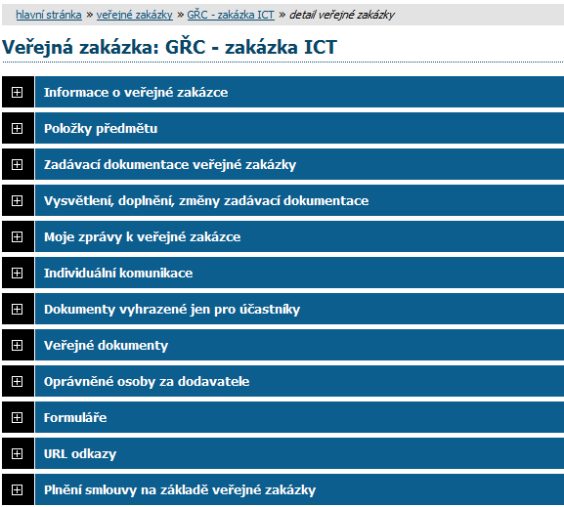
Information about the public tender (Informace o veřejné zakázce)
Tender documents (Zadávací dokumentace veřejné zakázky)
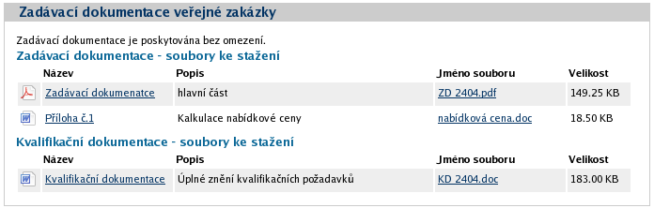
To download the tender documents click on the link in the third column (Jméno souboru).
Explanation, additions and amendments to the tender documents (Vysvětlení, doplnění, změny zadávací dokumentace)
Via this section, each registered supplier is able to ask the contracting authority for additional information (Poslat žádost o vysvětlení zadávací dokumentace). The answer to the supplier’s request will be delivered to this section as well.
My messages in the tender procedure (Moje zprávy k veřejné zakázce)
Each registered supplier might read internal messages in this section by clicking on the link in the column “Předmět”). Users are informed about every incoming message via email.
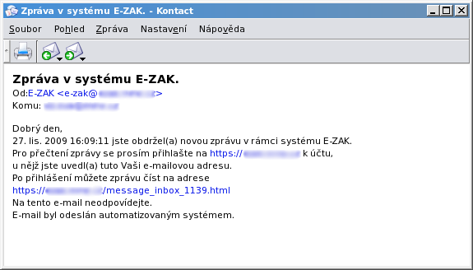
Individual communication (Individuální komunikace)
Documents reserved only for participants (Dokumenty vyhrazené jen pro účastníky)
Public documents (Veřejné dokumenty)
Supplier’s authorized persons (Oprávněné osoby za dodavatele)
Forms (Formuláře)
URL links (URL odkazy)
Submitted electronic tenders (Odeslané elektronické nabídky)
Public contract performance (Plnění smlouvy na základě veřejné zakázky)

- Tender submitting
A tender has to be submitted within the time limit for the submission of tenders.
1. step:
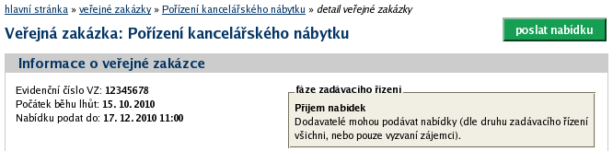
To submit a tender, first click on the green link “Poslat nabídku”. A form to compile the tender launches.
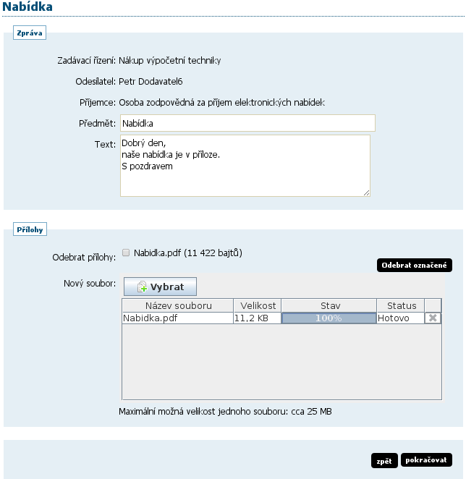
2. step: Subject Matter: Tender (Předmět: Nabídka); Short message/description (Text); Attachments (Přílohy) – Delete attachment (Odebrat přílohy)/New file (Nový soubor)→Select (Vybrat); Back (Zpět)/Continue (Pokračovat)
3. step: Electronic signature or click on the link “Obejít elektronický podpis“ to skip this requirement.
4. step: You will receive an automatic message about the tender submitting and you can also check the status in the section Odeslané elektronické nabídky.
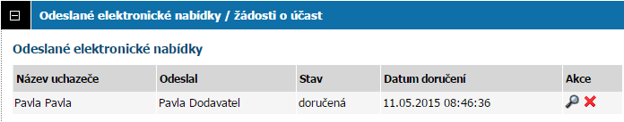
Status of the tender: delivered (doručená), void (zneplatněná), late delivery – automatically rejected (doručená po lhůtě), opened (otevřená), complete (úplná), incomplete (neúplná)

